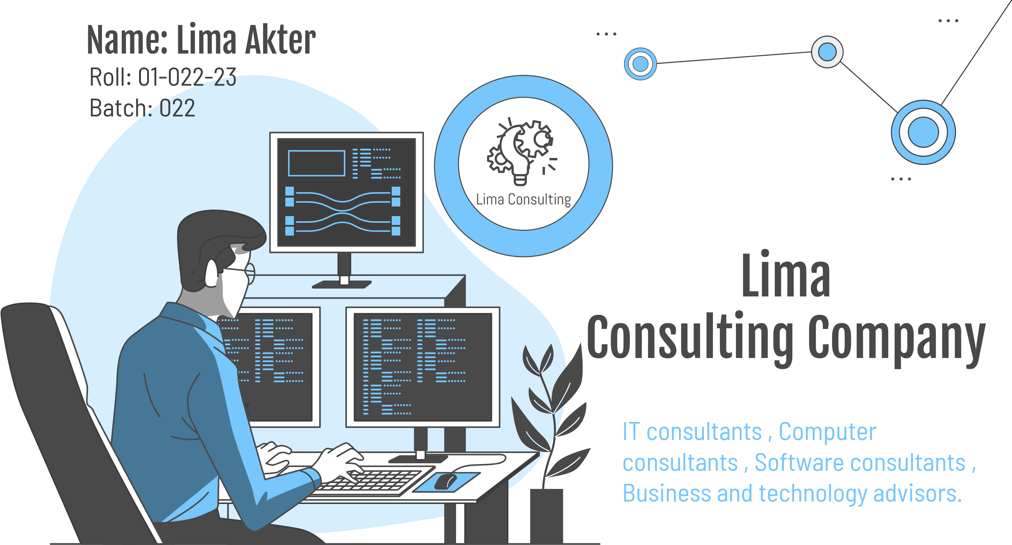

 Table of Contents

**Our consultants**

* IT consultants
* Computer Consultants
* Software consultants
* Business and Technology advisors

**Market Analysis and Target**

Research marketing and sales strategies and brands relative strengths and weaknesses.

**Problem & Solution**

Skilled manpower, Data security, Flaws in Execution, Artificial Intelligence, Take over etc.

01

02

03

04

**Our Processes**

* Identify the most and least valuable markets.
* Develop buyer personas.
* Find gaps in the market to fill.
* Assess the viability of a product or service.
* Improve business strategy.

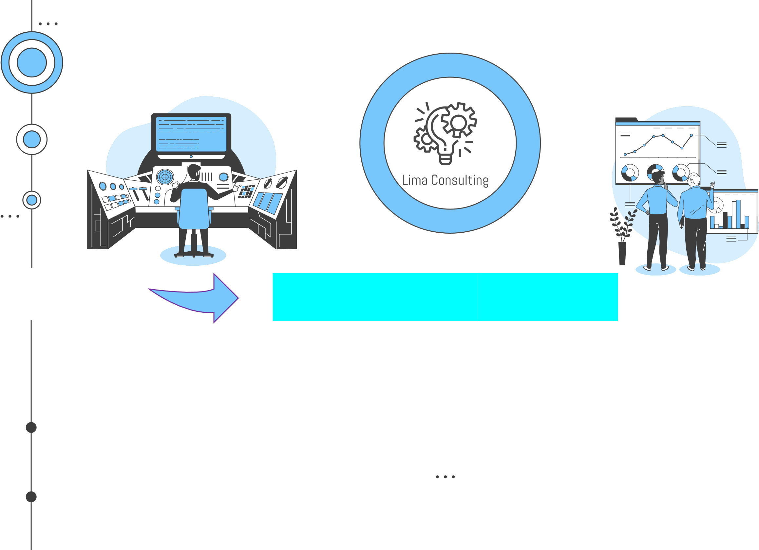Te

**Our Company Summary**

Tech Consultants analyze existing systems and processes within our own company and our clients’ organizations to develop technological strategies and provide solutions. We are responsible for planning and installing hardware and software, and addressing support requests from employees and clients.

**Our Product and Services**

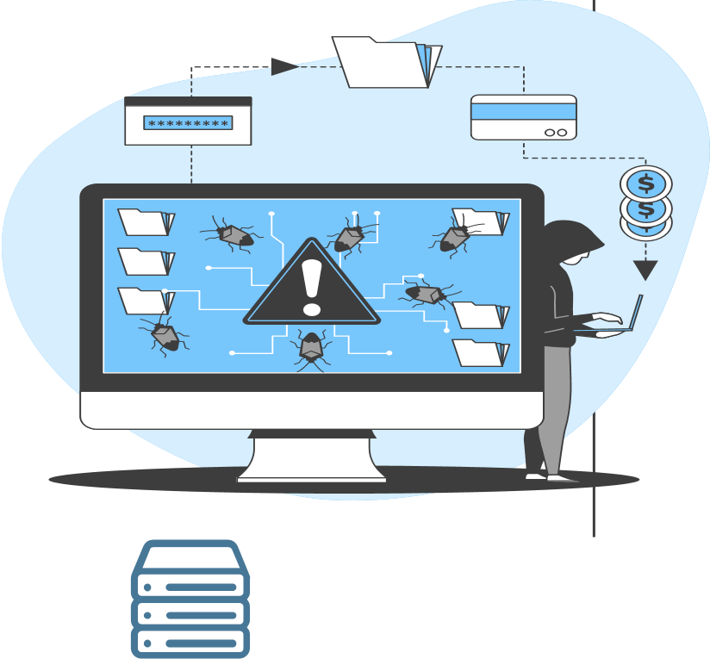

**Understanding the Problem**

**IT Business**

Lack of Qualified IT personnel. Careless approach to online security. Low IT workshop attendance and No Emergency Plan. Unreliable internet.

**Software**

Find out a defect in the software distribution media and or software function which is inconsistent with the software specification.

**Data**

Data security. The quantities, characters, or symbols on which operation are performed by a computer, which may be stored and transmitted in the form of electrical signals.

**Our Solutions / Services**

01 Software

Custom software development. We use technology and data science to build a comprehensive plan that goes beyond simply "installing a new IT system."

02 Planning

Comprehensive ERP (Enterprise Resource Planning). Enterprise performance management. ERP software can be remarkably complex.

03Security

Stronger cyber security. Civilian and defense clients to protect information systems and data.

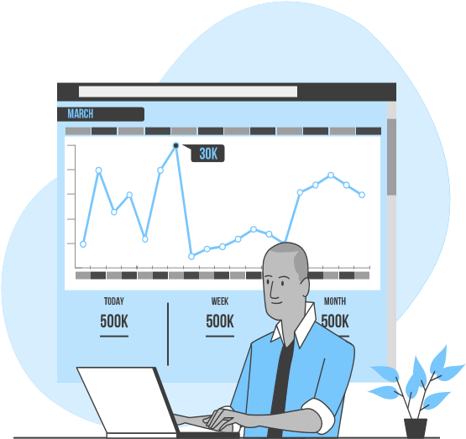04 Maintainance

Help with governance, risk, and compliance

10%

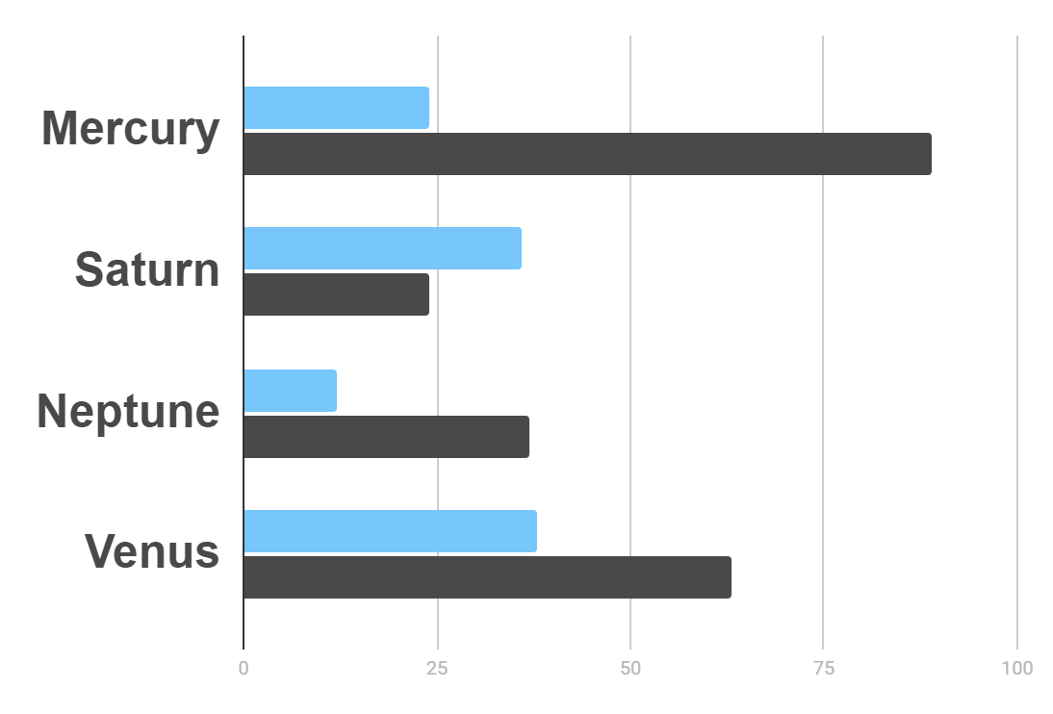

Market Research

K

45

Sector Growth

$20K

Gross Revenue in the Sector

10

%

Hyperlink

Here is the hyperlink added

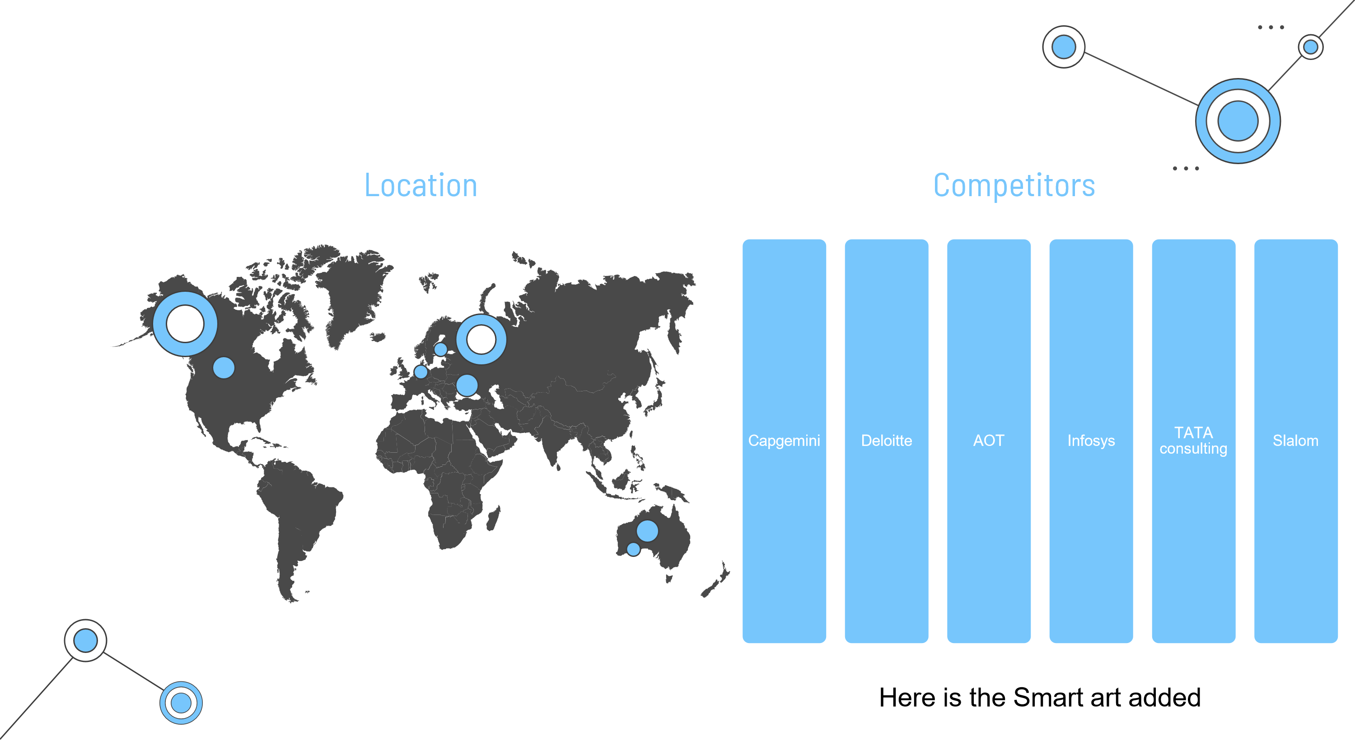

Competitor Analysis

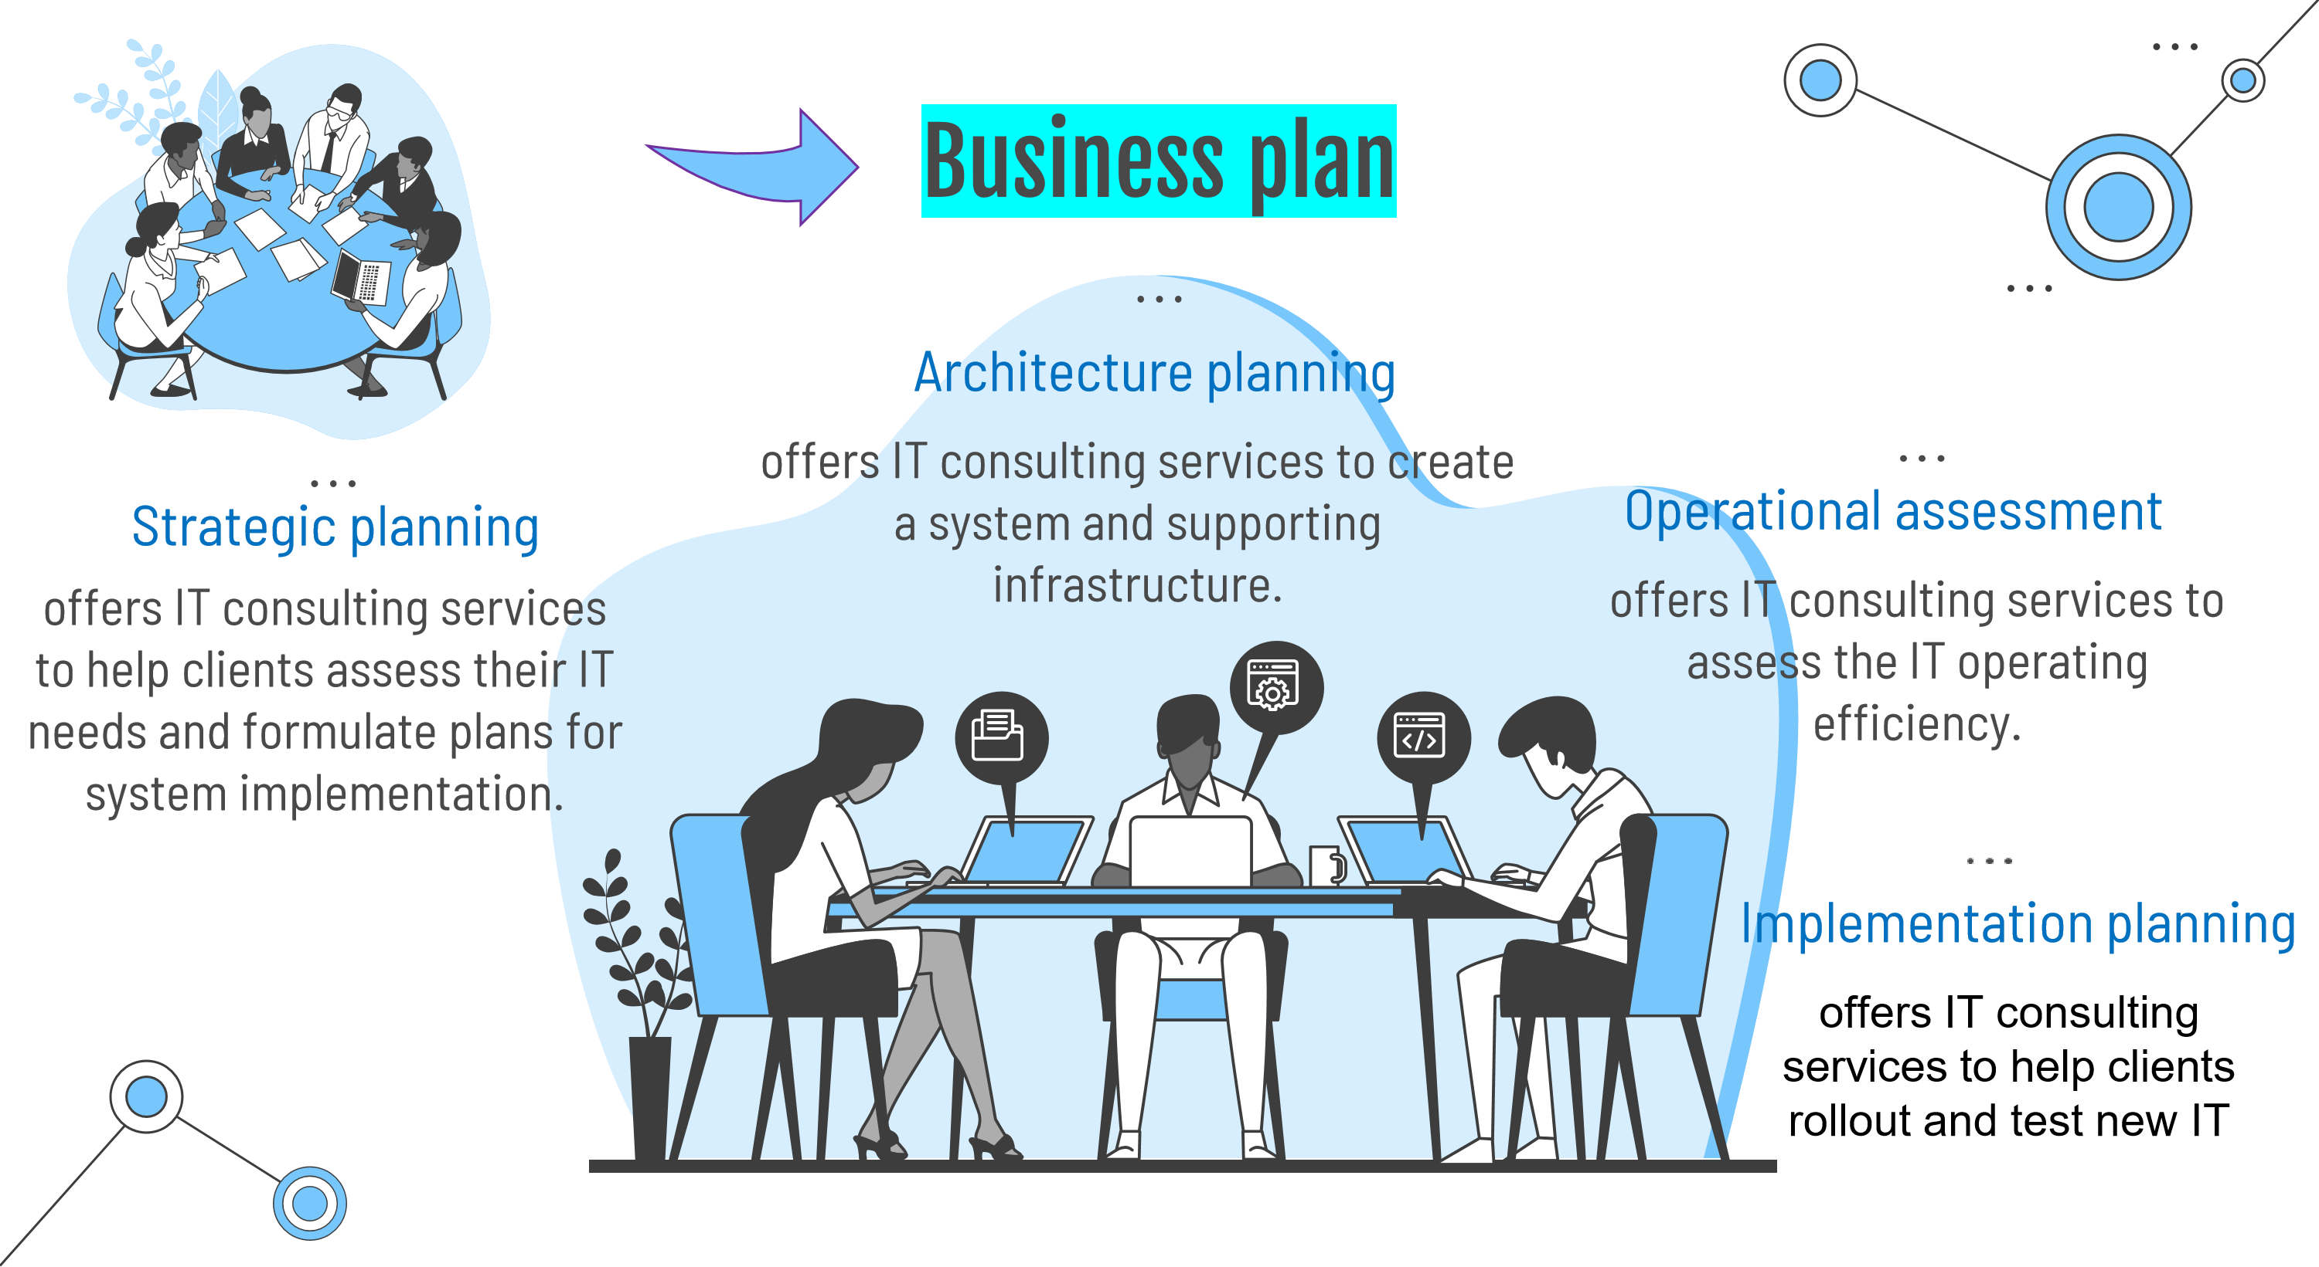

Target

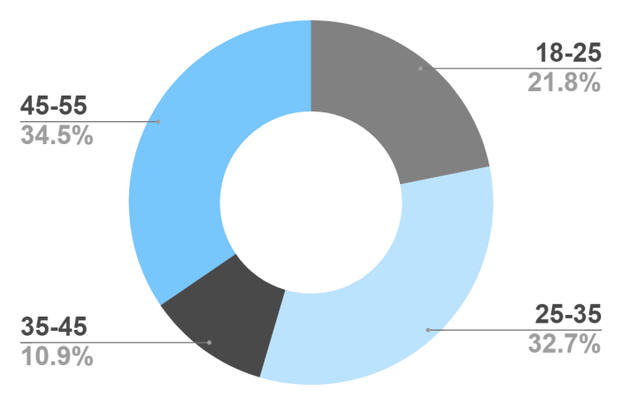

**Interests**

**Security**

**Usability**

**Our Process**

Custom software development

**Stronger cyber security**

Comprehensive ERP

(

Enterprise Resource Planning)

Help with governance,

risk, and compliance

S

tep

1

Step

2

Step

3

Step

4

**Priceater house**

IBM is the ringed one and a gas giant

Cap gemini

being red, Mars is actually a cold place

McKinsey

is the second highest earning company from the lima con.

Priceater house

is the farthest company from the lima con.

Accenture is the biggest company of them all

**Accenture**

**Cap gemini**

**McKinsey**

Deloitte is the closest IT consulting company to the Lima con

**IBM**

**Deloitte**

Our Partners

Sales and cost statistics

2024

2025

2026

2027

Goal 1

Phase 1

Phase 2

Making quality controls

Improves business processes

security consultants.

Maximizes any tech opportunities

Reduces costs

Performing studies

# …Statistics

|  |  |  |  |
| --- | --- | --- | --- |
| Year | Vision | Mission | Values |
| 2024 | 0.06 | 0.38 | 0.38 |
| 2025 | 0.11 | 0.53 | 0.38 |
| 2025 | 95.2 | 9.4 | 1.16 |

